

**DATABASE  
  
REQUIREMENT**

**SPECIFICATION**

***GDVInventoryDB - Customer & Inventory Database***

**Govinda Design & VISTAPrint**

Group Members:

I. Jun Leung 1026876

* II. Fabio Persaud 1027696
* III. Vidyanand Gayadeen 10115206
* IV. Nevin Beeraspat 1015843
* V. Harideva Dhanesar 1026614

**Dated:** September, 2018

**Revision Sheet**

|  |  |  |
| --- | --- | --- |
| **Release No.** | **Date** | **Revision Description** |
| Rev. 0 | 10/19/18 | Database Specifications Template and Checklist |
|  |  |  |
|  |  |  |
|  |  |  |
|  |  |  |
|  |  |  |



|  |  |
| --- | --- |
|  | **Database Specifications Authorization Memorandum** |

I have carefully assessed the Database Specifications for the GDVInventoryDB. This document has been completed in accordance with the requirements of the HUD System Development Methodology.

MANAGEMENT CERTIFICATION - Please check the appropriate statement.

______ The document is accepted.

______ The document is accepted pending the changes noted.

______ The document is not accepted.

We fully accept the changes as needed improvements and authorize initiation of work to proceed. Based on our authority and judgment, the continued operation of this system is authorized.

_______________________________ _____________________

HARIDEVA DHANESAR DATE

Project Leader

_______________________________ _____________________

JUN LEUNG DATE

Database programmer

_______________________________ _____________________

FABIO PERSAUD DATE

Database Administer

_______________________________ _____________________

VIDYANAND GAYADEEN DATE

Database analyst

_______________________________ _____________________

NEVIN BEERASPAT DATE

Database enginner

**TABLE OF CONTENTS**

1.0 GENERAL INFORMATION 6

1.4 Problem Statement 6

1.1 Purpose 6

1.3 System Overview 7

1.5 Point of Contact: 7

1.5.1 Information 7

1.5.2 Data owners 7

2.0 DATABASE IDENTIFICATION AND DESCRIPTION: 8

2.1 Naming conventions 8

2.2 Database identification 8

2.3 Systems using the database 9

2.4 Physical design 9

3.1 Responsibility 10

3.2 System information 10

3.2.1 Hardware configuration 10

3.2.2 Security 10

3.3 Storage Requirements 10

3.3 Recovery 11

3.4 Database interface 11

3.5 Error Handling 11

CONCEPTUAL DATABASE DESIGN 12

Entities 12

Attributes 13

➢ Inventory 13

➢ Customers 13

➢ Suppliers 14

*Primary key* 14

RELATIONSHIP BETWEEN ENTITIES 15

ATTRIBUTES OF THE RELATIONSHIP BETWEEN ENTITIES 15

The association between suppliers and inventory 15

The relationship between customers and inventory 16

Entity relationship model 17

LOGICAL DATABASE DESIGN 18

Selection of DBMS 18

Database Schema 18

Developer’s information and responsibilities 19

# GENERAL INFORMATION

This database management system will replace the physical documents used by Govinda Design & VISTAPrint for managing daily inventory and customer information. Moreover, the information will be stored, organized and manipulated by end users in a more efficient and effective manner, in turn, this will provide greater labour productivity.

## 1.4 Problem Statement

Govinda Design & VISTAPrint is a locally established printery in Guyana. It has been supplying locals with a vast amount of invitations imported from India, which are furthered edited to satisfy customer’s needs.

However, the established printery have not been able to properly manage the amount of invitations bought, as well as the amount sold to the various buyers. Due to the lack of any efficient management system, senior officials, as well as regular staffs have faced tremendous problems as it relates to reckoning of available stocks and the quantity of invitations that is sold on a daily basis.

Nonetheless, through the use of an efficient management system, Govinda Design & VISTAPrint can be able to effectively manage stocks available and invitations sold on daily basis. More so, this accurate record keeping management system can be used to monitor the designs of invitation that are most appealing to customers, which will further aid in decision making of future purchases.

## 1.1 Purpose

The purpose of the requirement’s specification is to meticulously analyze the acquired information. The latter accounts for both technical and non-technical information. Moreover, after analysis, solutions will be formulated to eradicate present problems relating to data management, as well as prevent any future mishaps.

**1.2 Scope**

This database management system focuses on managing inventory and customer information of Govinda Design & VISTAPrint in a more efficient and effective way. Through the use of a database management system, information will be organized, stored and manipulated. In turn, this will provide a storage structure for faster query processing, more so, increasing the efficiency of the business and decreasing the workload for its users.

## 1.3 System Overview

GDVInventory will be developed as an open source software based on technical and non-technical information gathered from Govinda Design & VISTAPrint. More so, it is a web-based system implementation that will provide a simple mechanism for users to store, organize and manipulate information in an efficient and effective manner.

|  |  |
| --- | --- |
| **Overview** | **Details** |
| Organization | Govinda Design & VISTAPrint |
| System name | GDVInventoryDB |
| System category | Main application |
| Operational status | Under development |

## 1.5 Point of Contact:

### 1.5.1 Information

|  |  |  |  |  |
| --- | --- | --- | --- | --- |
| **Role** | **Name** | **Email address** | **Contact number** | **Details** |
| Manager | Chaitram Dhanesar | [prabhupadadeva@gmail.com](mailto:prabhupadadeva@gmail.com) | 592-222-4912 | Mainly responsible for keeping records of customer/inventory information |
| Staff | Jairam Ramnarine | jairamramnarine.jr@gmail.com | 592-630-3501 | Accesses/modifies stored information for querying purposes |

### 1.5.2 Data owners

Data owners are those points of contact who either own or are responsible for data quality, currency, accuracy, etc.

|  |  |
| --- | --- |
| **Owner** | **Details** |
| Manager | Mainly responsible for information relating to customer and inventory |

# 2.0 DATABASE IDENTIFICATION AND DESCRIPTION:

## 2.1 Naming conventions

Naming conventions are the logical and physical naming standards and conventions.

Inventory table will include information about stocks available:

* Item_ID – unique ID of the varying designs of information
* Item_Name – refers to the names of the varying invitations
* Item_Amount – refers to the amount of invitations
* Item_Price – refers to the cost of certain invitations
* Item_Description – describes the varying invitations

Customer’s table will include information relating to various customers:

* Customer_ID – unique ID of the varying customers
* Customer_firstname – refers to the customer’s first name
* Customer_lastname – refers to the customer’s last name
* Customer_contact – refers to the contact number of the customer
* Customer_email – refers to the email address of the customer
* Customer_description – describes the customers

Supplier’s table will include information about the various suppliers:

* Supplier_ID – unique ID of the suppliers
* Supplier_name – refers to the name of the supplier’s business
* Supplier_address – refers to the supplier’s address
* Supplier_contact – refers to the contact number of the supplier
* Supplier_email – refers to the email of the supplier
* Note – refers to any additional information on the supplier

## 2.2 Database identification

**T**he database will utilize three tables, namely, inventory, customer and supplier. This will be used for recording relevant information needed to effectively manage Govinda Design & VISTAPrint.

* Inventory – Item_ID, Item_Name, Item_amount
* Customer – Customer_ID, Customer_firstname, Customer_lastname, Customer_contact, Customer_email, Customer_description
* Suppliers - Supplier_ID, Supplier_name, Supplier_address, Supplier_contact, Supplier_email, Note.

## 2.3 Systems using the database

* Manager’s system

This system will be used by the manager to record customer, as well as inventory information. In turn, this will be used for effective query processing, as well as other business needs.

* Staff’s system

This system will be used by the staffs of Govinda Design & VISTAPrint who requires information relating to customer/inventory.

## 2.4 Physical design

The diagram below shows standard systems which saves information through cloud storage. Through the use of such method, customer and inventory information can be entered and stored onto the cloud. In addition, information can be gathered from the cloud as needed by the manager and staffs of Govinda Design & VISTAPrint.

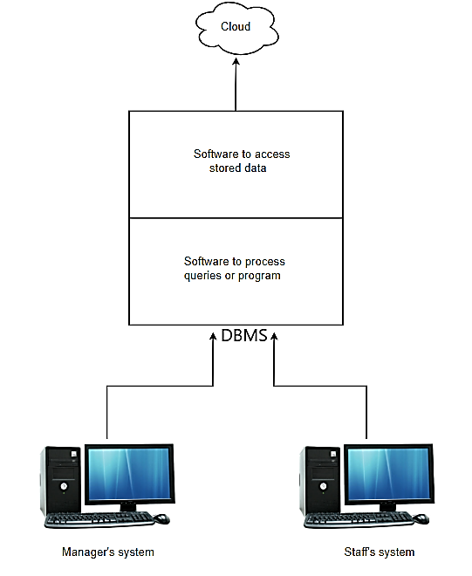

**2.5 Special instruction**

Persons would need to enter login credentials in order to access/modify data. This will be done to ensure that data will not be modified by unauthorized personnel.

3.0 DATABASE ADMINISTRATIVE INFORMATION

## 3.1 Responsibility

|  |  |
| --- | --- |
| **Role/function** | **Responsibility** |
| Database administrator | * Create/modify information * Grant user privileges to different users * Monitor the overall database for bugs and errors |

## 3.2 System information

### 3.2.1 Hardware configuration

|  |  |
| --- | --- |
| **Hardware** | **Details** |
| Ram | 8 Gb |
| Hard disk | 750 Gb |
| Operating system | Windows 7/8/10 |
| CPU | Intel core i3 or newer versions |
| Internet | Minimum 2 Mbps |
| Peripherals | Monitor, mouse, keyboard |

### 3.2.2 Security

* GDVInventoryDB offers the assurance of security through the use of credentials login, this enables users to view or modify data according to their level of user privilege granted by management
* GDVInventory has an auto logout feature to prevent malicious users from accessing/modifying unauthorized data.

## 3.3 Storage Requirements

The use of a 750 Gb hard drive to store records of inventory and customer’s information. This will be used as alternative storage mechanism to ensure that information is saved and later backed up on cloud storage.

## 3.3 Recovery

Details of information is primarily stored in cloud for fast recovery of information if GDVInventoryDB crashes. Additionally, the company owns an alternative storage mechanism (hard drive) which can be used to back up the database on a weekly basis or as required by the owner.

## 3.4 Database interface

Graphical user interface

This will provide a friendly user interface. This will be used to provide an effective feedback to end users, more so, respond to interactions in an efficient and friendly manner.

## 3.5 Error Handling

* The DBMS ensures that data integrity is maintained. This accounts for monitoring and ensuring that the required data is been entered by users, more so, this prevents any future mishaps/malfunctions due to any erroneous identification of data.
* In cases of cloud storage failures, daily information is stored on computer hard drives to restore program to a valid state.

# CONCEPTUAL DATABASE DESIGN

# Entities

The entities of Govinda Design & VISTAPrint that relates to the database design includes:

* Inventory

Inventory refers to the list of invitations that are currently in stock at Govinda Design & VISTAPrint.

* Suppliers

Suppliers refers to those companies that supplies invitations to Govinda Design & VISTAPrint.

* Customers

This refers to those individuals or group of individuals who purchases invitation from Govinda Design & VISTAPrint.

# Attributes

Attributes refers to those characteristics of the entities that are relevant to the database design:

## Inventory

* *Quantity of invitations*

Keeping record of the quantity of the invitations will ensure reckoning of stocks is done in a timely manner. In addition, it will ensure that the varying designs of invitations are available.

* *Specific identification number*

Assigning unique numbers to the varying designs of invitations aids in identifying invitations needed by staffs.

* *Wholesale and retail prices*

Storing of prices will ensure that queries or purchases are processed in a more efficient manner.

* *Description of invitation*

Brief descriptions of invitations will ensure queries related to stocks are acknowledged in an effective manner.

## Customers

* *Names of customers*

Allows monitoring of those individuals who purchases large quantities of invitations. Moreover, it will assist Govinda Design & VISTAPrint while making decisions relating to

marketing strategies.

* *Unique identification number*

Assigning unique numbers to customers alleviates any possible erroneous identification of customers.

* *Quantity*

Allows monitoring of the quantity of invitations bought by various individuals from Govinda Design & VISTAPrint, in turn, this will be used to target potential customers.

* *Contact information*

Storing of information such as contact number and email address enhances communication between customers and Govinda Design & VISTAPrint needed for business purposes.

* *Note for customers*

This provides the manager with the ability to create information about customers, which in turn, might be needed for future business references.

## Suppliers

* *Name of suppliers*

This will enable the manager to keep track of those suppliers that supplies invitations needed by Govinda Design & VISTAPrint.

* *Specific identification number*

Assigning unique numbers to suppliers alleviates any possible erroneous identification of suppliers within management.

* *Contact information*

Storing of information such as contact number and email address enhances communication between suppliers and Govinda Design & VISTAPrint needed for business purposes.

* *Address*

Storing addresses serves to provide information needed when making physical tradeoffs, as well as other business purposes.

* *Note for suppliers*

This provides the manager with the ability to create information about suppliers, which in turn, might be needed for future business references.

# *Primary key*

Primary key refers to the key that uniquely identifies an entity.

|  |  |
| --- | --- |
| Primary key | Entities |
| Specific identification number | Suppliers |
| Specific identification number | Inventory |
| Specific identification number | Customers |

# RELATIONSHIP BETWEEN ENTITIES

This refers to the association between suppliers, staffs and inventory. The association between suppliers and inventory can be seen as suppliers supplying invitations to Govinda Design & VISTAPrint’s inventory. In addition, the relationship between customers and inventory can be seen as staffs retrieving varying designs of invitations from inventory to satisfy customer’s needs.

## ATTRIBUTES OF THE RELATIONSHIP BETWEEN ENTITIES

## The association between suppliers and inventory

The attributes of the relationship between suppliers and inventory includes:

* *Quantity of invitation bought*

This refers to the amount of invitations that will be bought from suppliers. This information will be used to ensure that the quantity of stocks received are accurately accounted for.

* *Prices paid*

Keeping record of prices paid to suppliers is vital to management since accurate figures are needed during the pricing process.

* *Inventory identification number*

This accounts for the unique identification number of the items that will be supplied to inventory by suppliers. This ensures that invitation collected are being accounted for, more so, ensuring accurate reckoning of invitations.

* *Supplier’s identification number*

This alleviates any possible erroneous identification of suppliers within management.

## The relationship between customers and inventory

The attributes of the relationship between inventory and customers includes:

* *Inventory identification number*

This accounts for the unique identification number of the items that will be retrieved by staffs from inventory. This ensures that invitation collected are being accounted for, more so, ensuring accurate reckoning of invitations.

* *Quantity of invitations*

This is concerned with the amount of invitations that will be collected from inventory by staffs. This will be used to ensure that stocks are always available, as well as alleviate any possible irregular activities such as missing invitations.

* *Customers identification number*

This is concern with the unique identification number that is assigned to customers. This will enable managers to accurately monitor customers and the quantity purchased by the latter.

# 

# Entity relationship model

The ER model below graphically depicts the entities of Govinda Design & VISTAPrint that relates to the database design. In addition, it includes relationships among those entities, as well as attributes of the entities and the relationships.

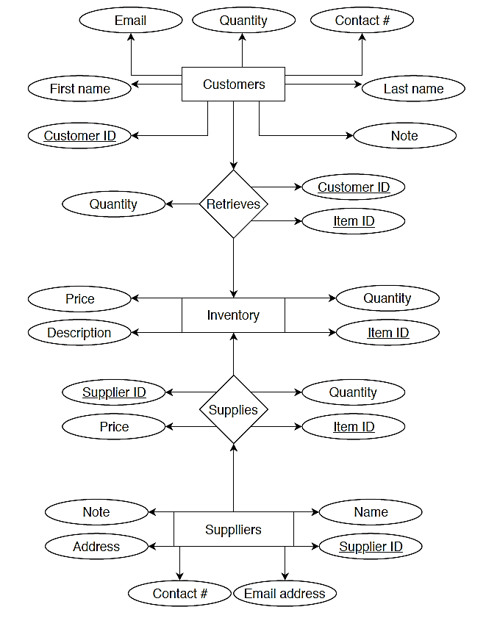

# LOGICAL DATABASE DESIGN

## Selection of DBMS

The selected DBMS is MySQL. This is an Open Source Database Management System which is developed and supported by Oracle Corporation. It is a quite popular language for database management. It uses administration tools like phpMyAdmin to handle it over the Web.

## Database Schema

The data types below accounts for the attributes of each entity identified in the conceptual database design stage. In addition, the data types are specific to the chosen DBMS software that will be implemented as the database solution.

|  |  |  |
| --- | --- | --- |
| Entity | Attributes | Data types |
|  | Item ID | Integer (10) |
|  | Description | Text |
| Inventory | Price | Decimal (9,2) |
|  | Quantity | Integer (10) |
|  | Contact# | Varchar (20) |
|  | Note | Text |
| Customers | Customer ID | Integer (10) |
|  | First name | Varchar (15) |
|  | Last name | Varchar (15) |
| Suppliers | Contact# | Varchar (20) |
| Address | Varchar (40) |
| Note | Text |
| Email | Varchar (40) |
| Name | Varchar (40) |
| Supplier ID | Integer (10) |

|  |  |  |  |
| --- | --- | --- | --- |
| Attributes of relationship between Inventory & customers | Data types | Attributes of relationship between suppliers & inventory | Data types |
| Item ID | Integer (10) | Quantity | Integer (10) |
| Quantity | Integer (10) | Price | Decimal(9,2) |
| Customer ID | Integer (10) | Supplier Id | Integer (10) |
|  |  | Item ID | Integer (10) |

# Developer’s information and responsibilities

1. Harideva Dhanesar (Project Leader)

GitHub account: HariKirtanRasa

<https://github.com/HariKirtanRasa>

Responsibilities:

* Work alongside team members when demand and/or pending deadlines require it.
* To ensure the team have the necessary information and tools to be effective in their roles

1. Jun Leung (Database Programmer)

GitHub account: MasterJuneLeung

<https://github.com/MasterJuneLeung>

Responsibilities:

* Design, write and modify programs to improve application processing
* Performing tests to identify ways to solve database usage concerns and malfunctions.

1. Fabio Persaud (Database Administrator)

GitHub account: fabio-persaud

<https://github.com/fabio-persaud>

Responsibilities:

* Installs the database software and configures it for use.
* Create backup and recovery plans and procedures based on industry best practices

1. Vidyanand Gayadeen (Database Analyst)

GitHub account: vidyanandgayadeen

<https://github.com/vidyanandgayadeen>

Responsibilities:

* Ccontributes to team effort by accomplishing related results as needed.
* Protects database by developing access system; specifying user level of access.

1. Nevin Beeraspat (Database Engineer)

GitHub account: [NevinBeeraspat](https://github.com/NevinBeeraspat)

<https://github.com/NevinBeeraspat>

Responsibilities:

* Assist in design and development of database systems.
* Perform database maintenance and troubleshooting activities.